**Sequence Diagram:**

**Event Creation:**

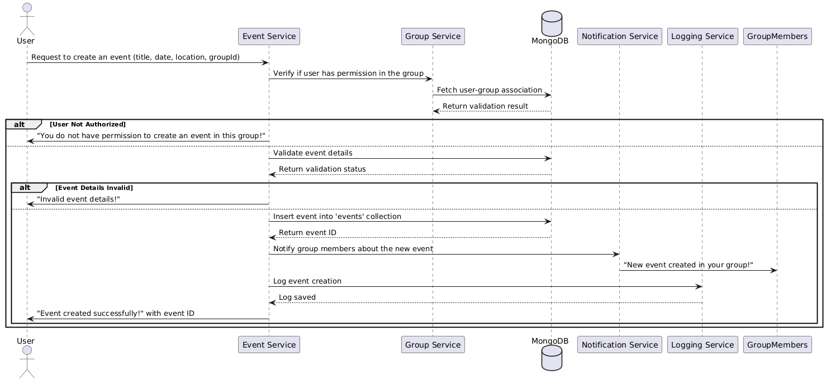

**Database**

**Functional Requirements (FRs)**

* **FR1:** The system shall validate event details such as title, date, location, and category.
* **FR2:** Only group admins and moderators shall be able to create events.
* **FR3:** Events shall be linked to the group they belong to.
* **FR4:** The system shall allow events to be created as "draft" or "published**".**

**Non-Functional Requirements (NFRs)**

* **NFR1:** The system shall support at least 10,000 concurrent event creations.
* **NFR2:** Event creation should not exceed 3 seconds.